Chapter 1
1.1:The Structure of Data
- Statistics is the science of collecting, organizing, summarizing, and analyzing information to draw conclusions or answer questions.
- Statistics is all about DATA
Collecting DATA
Describing DATA – summarizing, visualizing
Analyzing DATA
- We obtain information about cases or units.
Generally each case makes up a row in a dataset, and each variable makes up a column
- Variable
  - Characteristic that is recorded for each case.
  - Examples: Marital status, Height, Weight, IQ
- A variable can be classified as either
  - Categorical, or
  - Quantitative (Discrete, Continuous)
- A variable can be classified as Categorical if each observation belongs to one of a set of categories. Examples: Gender (Male or Female), make of car, Hair color

- A variable is called Quantitative if observations on it take numerical measures of individuals. Arithmetic operations such as addition and subtraction can be performed on the values of the quantitative variable and provide meaningful results.
Examples: Weight, Height, number of miles traveled to work.
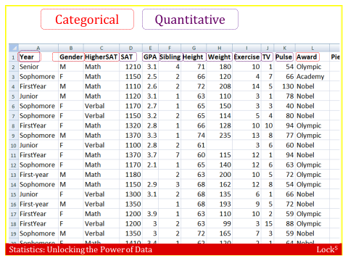
1.2: Sampling from a Population
- Researchers are often interested in learning about a group of people or things. The group they would like to learn about is known as the population. Unfortunately looking at every element in a population can be very difficult. Instead researchers will take a small group from the population to examine. This small group is known as the sample.
- 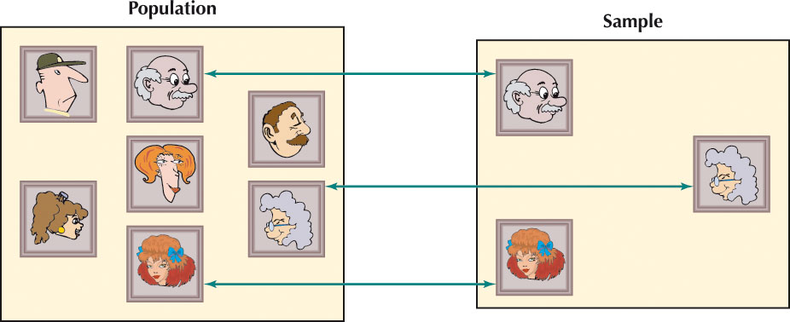
- A parameter is a numerical value summarizing the population data (The actual value of a population parameter is usually unknown)
- A statistic is a numerical value summarizing the sample data (We use this to estimate the parameter)

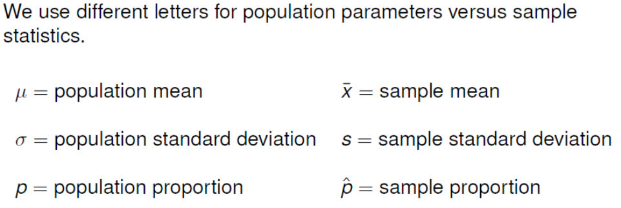
- Statistical inference is the process of using data from a sample to gain information about the population.

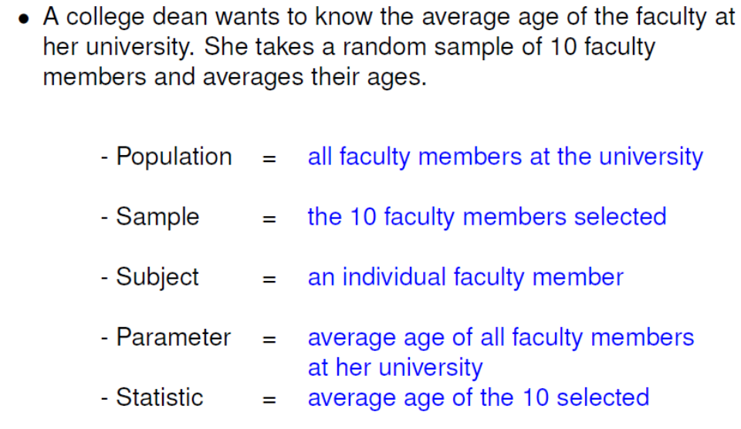
- Example: Number of Cell Phone Calls per Day
Princeton Survey Research reports on a survey of 1,917 cell phone users in the US, conducted in May 2010, asking “On an average day, about how many phone calls do you make and receive on your cell phone?”
- What is the sample in this study?
The 1,917 people who were asked the question.

- What is the population?
All cell phone users in the US

- Is the variable in this study quantitative or categorical?
Quantitative

What can go wrong?
Ideally we need the sample to reflect the population. If the sample does not reflect the population then we will not be able to make good statistical inference. When this occurs we call it Sampling Bias.

Sampling bias occurs when the method of selecting a sample causes the sample to differ from the population in some relevant way.
If sampling bias exists, we cannot trust generalizations from the sample to the population

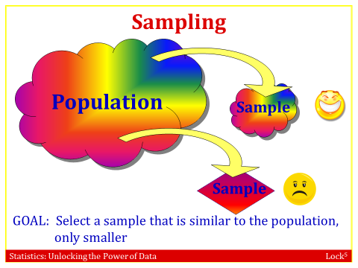
How do we avoid sampling bias?

- Random Sampling is the best way of obtaining a sample that is representative of the population
In a simple random sample, each unit of the population has the same chance of being selected, regardless of the other units chosen for the sample
Common way to do SRS: draw from a hat, use computer to randomly generate numbers, use table of random numbers
Only random samples can truly be trusted when generalizing to the population!
In other words, data from biased samples are not good estimates.
- Example: Driving with a Pet on your Lap
Over 30,000 people participated in an online poll on cnn.com conducted in April 2012 asking”Have you ever driven with a pet on your lap?” We see that 34% of the participants answered yes and 66% answered no.
- What is the sample?
The 30,000 people who participated in the poll
- Can we conclude that 34% of all drivers have driven with a pet on their lap?
No! This is a volunteer sample, and volunteer samples are aften biased. It is likely that people who have driven with a pet on their lap are more likely to respond to the poll.
(c) Explain why it is not appropriate to generalize these results to all drivers, or even to all drivers who visit cnn.com. What is the problem with this method of data collection?
Volunteer samples are generally biased since people who feel strongly about the subject are much more likely to participate.
- How might we select a sample of people that would give us results that we can generalize to a broader population?
Use a RANDOM SAMPLE!
- Is the variable in this study quantitative or categorical?
Categorical
- Example: Sampling Bias
You wish to estimate the number of hours a week that students at your university spend studying. For each sampling method below, indicate whether the results are likely to be representative of the entire student body or whether the method is likely to give biased results.
- Ask students you find at the library on a Friday night. Biased

- Ask students who are at a party on a Tuesday night. Biased

- Ask a random sample of students. Representative

(d) Ask the students in Organic Chemistry. Biased

- Ask all the students on one of the school’s athletic teams. Biased
- Send an email out to all students and use all the responses you get.
Biased – Volunteer sample
- Ask friends that you know, trying to get a reasonably representative group.
Biased – People are not good at this

- Does taking a random sample take care of bias?

No, even with a random sample, data can still be biased, especially when collected on humans
- Other things that can cause bias include the following:
People selected in the sample choose not to participate
Question wording
Inaccurate responses
Many other possibilities – examine the specifics of each study!
In practice, think hard about potential sources of sampling bias, and try your best to avoid them.
Example : Public Speeches against Democracy
How a question is worded can have a dramatic impact on the result. These two questions appear to be asking the same thing:
- “Do you think the US should allow public speeches against democracy?”
- “Do you think the US should not forbid public speeches against democracy?”
However, 21% said such speeches should be allowed (in answer to the first question) while almost double that (39%) said such speeches should not be forbidden (in answer to the second question). Why do you think the results were so different?
Even subtle changes in wording can have a strong effect on the outcome. In this case, it is likely that people don’t want to “forbid” something since it sounds very rigid compared to “not allowing”. Many other answers are possible. The key idea is that wording matters and can affect the outcome!

1.3: Experiments and Observational Studies

If we are using one variable to help us understand or predict values of another variable, we call the former the explanatory (independent) variable and the latter the response (dependent) variable.

Example: Suppose we are interested in determining if a person’s favorite starburst flavor explains the time they sleep each night in minutes.
The explanatory variable is Starburst flavor and it is a categorical variable.
The response variable is sleep time and it is a quantitative variable.

One of the reasons for collecting data is we would like to learn about the relationship between different types of variables. There are 2 different kinds of relationships that we need to distinguish between.
Two variables are associated if values of one variable tend to be related to values of the other variable
Two variables are causally associated if changing the value of the explanatory variable influences the value of the response variable
Key words:
Association: linked, “tend to”, likely
Association with Causation: Improves, “Leads to”
- Association does not imply causation!
Why do we sometimes see an association but there is no underlying causation?
- A third variable that is associated with both the explanatory variable and the response variable is called a confounding variable.
- A confounding variable can offer a plausible explanation for an association between the explanatory and response variables. Whenever confounding variables are present (or may be present), a causal association cannot be determined. Confounding variables are often present in observational studies.
Example :Television Sets and Life Expectancy
There is a very strong positive association between television sets per person in a country and the life expectancy of the people in that country, which means people in countries with lots of TVs tend to live longer.
- Does this mean we can improve the life expectancy of people in developing countries by sending them lots of television sets?
No! This strong association is not causation.
- Describe a possible confounding variable in this association.
The wealth of the countries is a confounding variable. Wealth will affect both the number of television sets and the life expectancy.
How do researchers gather data and study the variables?
We are going to discuss 2 ways that researchers gather data. Two major types of statistical studies are experimental studies and observational studies
- An observational study is a study in which the researcher does not actively control the value of any variable, but simply observes the values as they naturally exist.
- Experimental Studies: In an experimental study, A researcher conducts an experiment by assigning subjects to certain experimental conditions and then observing outcomes on the response variable. An experiment is a study in which the researcher actively controls one or more of the explanatory variables
Observational studies can almost never be used to establish causation!!
Example: Exercise and Depression
In each case below, we describe a study to determine whether exercise helps increase certain mood enhancing chemicals in the brain. Indicate whether each describes an experiment or an observational study.
- We contact a random sample of 100 people and record how much each person exercises and also measure the chemicals in the brain for each person.
Observational study. No variables were manipulated.
- Using a random sample of 100 people, we randomly assign half of them to participate in a regular exercise program for a six-week period while the other half makes no changes. At the end of the time period, we measure the brain chemicals.
Experiment. The experimenters actively imposed the explanatory variable (exercise or not).
- There are three main factors that should be considered when designing an experimental study: control, randomization, and replication.
Control
- A control group is necessary to compare against the treatment group
- In some experiments, members of the control group receive a placebo, a
nonfunctioning simulated treatment
- Members of the control group improve simply by taking the placebo, a phenomenon known as the placebo effect.
Randomization
- Many biases can be introduced into an experiment
- Eliminate biases
- Necessary to place subjects into the treatment and control groups randomly
Replication
- Larger samples are usually better
- Allow more precise inference
- Treatment and the control groups each must contain a large enough number of subjects to allow detection of meaningful differences between the treatment and control
- Only an experiment can establish cause and effect. Observational studies cannot.
- Example: Caffeine and Learning
Does ingesting caffeine help mice learn the way through a maze faster? Describe a well-designed randomized experiment to test this. Give all details, including the use of placebos and blinding. We have 20 mice to work with.
Solution : We randomly divide the mice into two groups of 10 mice each. We give half the mice caffeine in their food while the other group gets identical food without caffeine (placebo). We make the study double-blind by not telling the mice or anyone interacting with the mice (for example, whoever is timing the maze runs) which mice are getting the caffeinated food and which are not. We measure the time it takes for the mice to learn the maze and compare the results between the two groups.

